Key Period 5 (1844-1877) Political Cartoons
12.11 Title: ________________________________________________________________________________________
Circle and label notable aspects of the image:
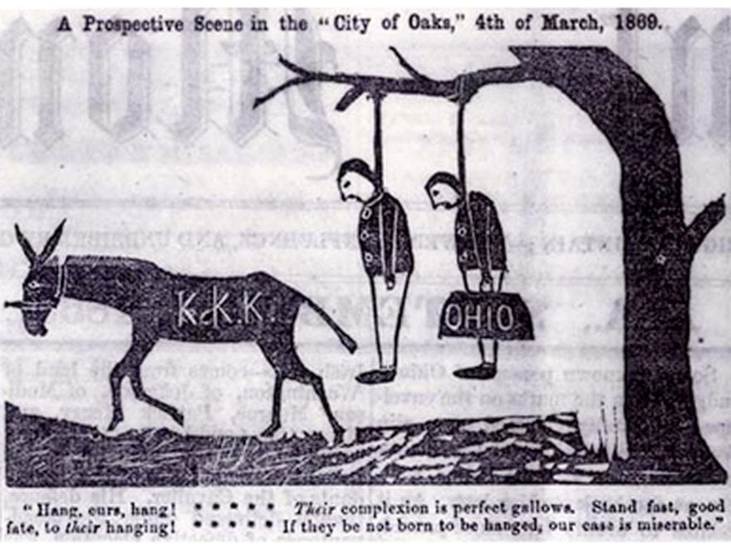

- What era of KP5 is this cartoon from?
- The Antebellum Era
- The Civil War
- Reconstruction
- The 1860 Election

- What were “carpetbaggers”?
- Northerners aiding Southern reconstruction
- Men who fled the South after the war
- KKK members who kidnapped blacks
- Southern planters who joined the KKK

- What were “scallawags”?
- Northern traitors of the Civil War
- Southerners sympathetic to emancipation
- Northerners forcing Southern reconstruction
- Southern planters who joined the KKK

- In KP5, what was the Ku Klux Klan?
A) a British terrorist group aiming to divide the U.S. further after the war
B) a Nativist organization aiming to prevent Mexican immigration at all costs
C) a secret organization aiming to suppress the newly acquired power of blacks
D) a segregated “utopian” society for Southern racists after the Civil War
HIPPOS notes (NOT full sentences):

H-

I-

P-

P-

O-

S-

12.13 Title: ________________________________________________________________________________________
Circle and label notable aspects of the image:

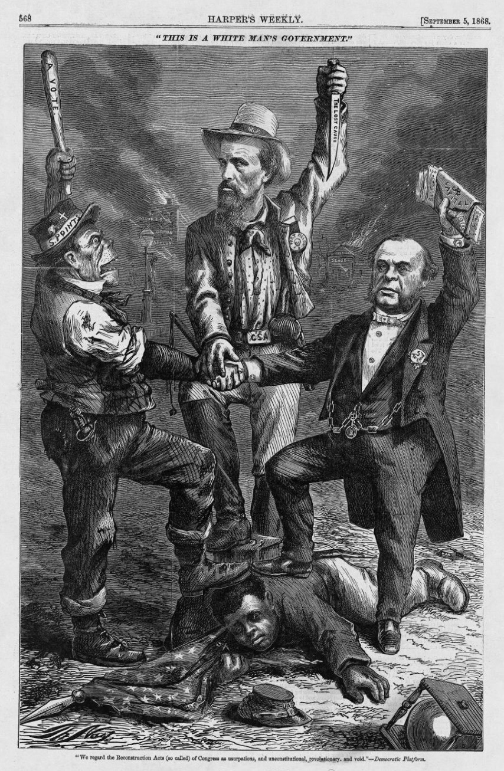
- Which of the following were the Irish-Americans judged for?
- Heavy-drinking
- Being Catholics
- Increasing the Democratic Party’s votes
- All of the above
- Who is the man in the top middle?
A) Irish-American man
B) August Belmont (DP chair)
C) Nathan Forrest (KKK)
D) a union soldier

HIPPOS notes (NOT full sentences):

H-

I-

P-

P-

O-

S-

"We regard the Reconstruction Acts (so called) of Congress as usurpations, and unconstitutional, revolutionary, and void." - Democratic Platform

- What is this cartoon representative of?
A) The Republican Party’s rebellious branches
B) The post-war Democratic Party as anti-Reconstruction
C) Southern victories of the civil war
D) the failures of abolitionism in the South

- Which of the following did the 15th Amendment grant?
- black male suffrage
- priority of women’s rights
- Irish citizenship
- No KKK in office

