Key Period 5 (1844-1877) Political Cartoons
Anti-Reconstruction Cartoon Independent Monitor
12.11 Title: ________________________________________________________________________________________
Circle and label notable aspects of the image:
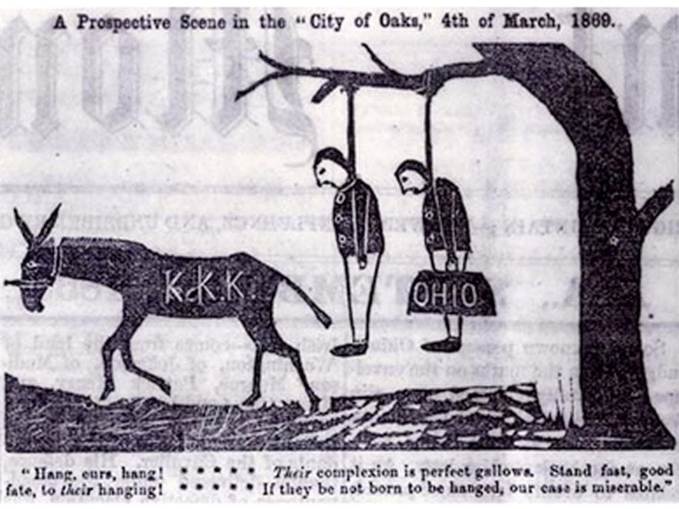

- What era of KP5 is this cartoon from?
- The Antebellum Era
- The Civil War
- Reconstruction
- The 1860 Election

- What were “carpetbaggers”?
- Northerners aiding Southern reconstruction
- Men who fled the South after the war
- KKK members who kidnapped blacks
- Southern planters who joined the KKK

- What were “scallawags”?
- Northern traitors of the Civil War
- Southerners sympathetic to emancipation
- Northerners forcing Southern reconstruction
- Southern planters who joined the KKK

- In KP5, what was the Ku Klux Klan?
A) a British terrorist group aiming to divide the U.S. further after the war
B) a Nativist organization aiming to prevent Mexican immigration at all costs
C) a secret organization aiming to suppress the newly acquired power of blacks
D) a segregated “utopian” society for Southern racists after the Civil War
HIPPOS notes (NOT full sentences):

H- Tuscaloosa, Alabama newspaper; 1868 (post-war); Reconstruction era; political cartoon

- “carpetbaggers” and “scalawags”, pro-Reconstruction Americans

P- to give a public threat to those supporting Reconstruction

P- Southern perspective (they just lost a war and they are ANGRY!), likely created by KKK members

O- 13th Amendment (slavery abolished in U.S.), 14th (born in U.S.=citizen, no Confederates in office), 15th (black male suffrage)
An example of post-war animosity between North and South

S- Reconstruction can be compared to the Civil Rights Movement (1960s), sects of the KKK still exist today

12.13 Title: ________________________________________________________________________________________
Thomas Nast, "This is a White Man's Government"
Circle and label notable aspects of the image:

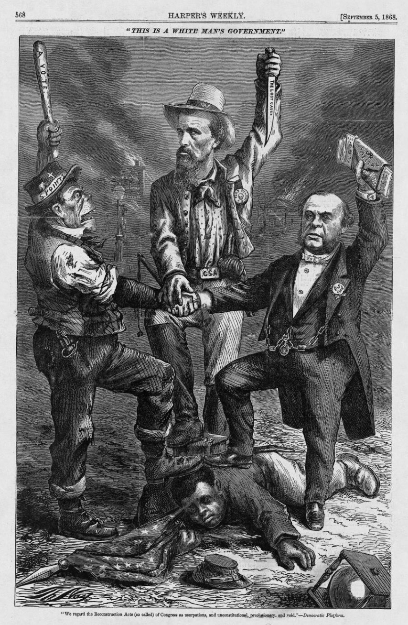

Reconstruction, 1874, surfaced in Harper’s Weekly, political cartoon

pro-Reconstruction Americans, Republicans, Democrats

to convey Nast’s belief that the Democratic Party posed a threat to the safety of and suppressed the rights of African Americans after the Civil War through depictions of corrupt Democrats (what Nast considered the three dominant wings of the post-war party), "We regard the Reconstruction Acts (so called) of Congress as usurpations, and unconstitutional, revolutionary, and void.” = “We don’t want Reconstruction, this is a white man’s government”

Thomas Nast has created many political cartoons (Elephant and Donkey, Tanney Tiger), recognizes societal issues, heavy symbolism, pro-Reconstruction

13th Amendment (slavery abolished in U.S.), 14th (born in U.S.=citizen, no Confederates in office), 15th (black male suffrage)

Reconstruction can be compared to the Civil Rights Movement (1960s)
- Which of the following were the Irish-Americans judged for?
- Heavy-drinking
- Being Catholics
- Increasing the Democratic Party’s votes
- All of the above

- Who is the man in the top middle?
A) Irish-American man
B) August Belmont (DP chair)
C) Nathan Forrest (KKK)
D) a union soldier

HIPPOS notes (NOT full sentences):

H-

I-

P-

P-

O-

S-

"We regard the Reconstruction Acts (so called) of Congress as usurpations, and unconstitutional, revolutionary, and void." - Democratic Platform

- What is this cartoon representative of?
A) The Republican Party’s rebellious branches
B) The post-war Democratic Party as anti-Reconstruction
C) Southern victories of the civil war
D) the failures of abolitionism in the South

- Which of the following did the 15th Amendment grant?
- black male suffrage
- priority of women’s rights
- Irish citizenship
- No KKK in office

