Name_________________

Date________

Period___

Dred Scott Vs SandFord

1. **Who was Dred Scott?**

H:

I:

P:

P:

O:

S:

1. Slave B. Lawyer

C. Slave Owner D. None of the above

**2. What year did the case happen?**

A. 1861 B. 1855

C. 1857 D. 1860

**3. Was Taney for slavery or against?**

A. Pro-Slavery B. Anti-Slavery

**4. What happened 3 years after the Dred**

**Scott Decision?**

1. Civil War B. South Succeeds

C. Panic of 1857 D. Missouri Compromise

**5. Did Dred Scott win the case?**

1. Yes B. No

Name___________

Date_________

Period___

**The Emancipation of Negroes, January 1863, the past and the Future**

**3. What word is on the stove?**

A. Union B. CSA

C. USA D. Confederacy

**4. What is happening to the slaves in the bottom left?**

A. Working B. Being beaten

C. Arguing D. Escaping

H:

I:

P:

P:

O:

S:

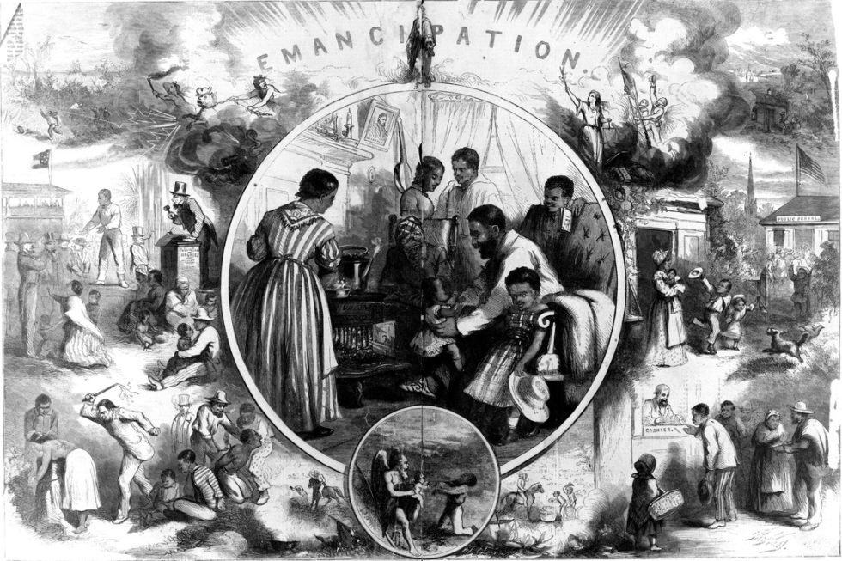

1. **What word is on the top of the picture**
2. Freedom C. Slavery
3. Union D. Emancipation
4. **Who is on the picture on the wall inside**

**the bubble?**

1. Washington C. Adams
2. Lincoln D. Johnson