Key Period 5 (1844-1877) Inaugural Speeches
Title:
Observe this piece of historical sweg!
HIPPOS notes ( Does NOT have to be in full sentences):

H-

I-

P-

P-

O-

S-

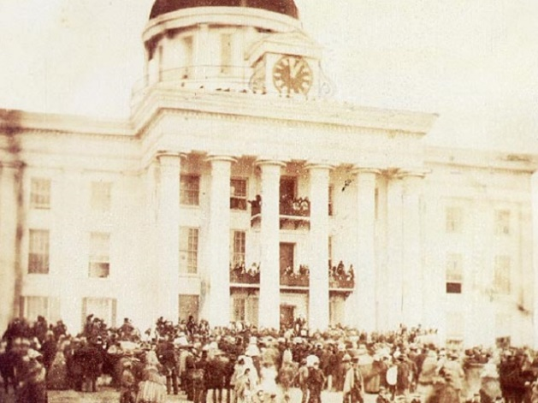
- Where was this photo taken?
- The Secret Illuminati Capital
- Alabama State Capital
- The White House
- Plantation owner’s home
- What was Jefferson Davis the president of?
- The Mushroom Kingdom
- The United States of America
- The Confederate States of America
- The Pokémon Fan Club
- What was the Confederacy fighting for?
- The Liberation of France
- The Last $100 100 inch TV on Black Friday
- The preservation of Slavery
- The end of Slavery
- Why did the Confederate States Secede?
- Lincoln ate a Southerner’s cookies
- The production of Doritos has stopped
- Lincoln winning the Election of 1860
- They found out the apush final isn’t curved

Key Period 5 (1844-1877) Inaugural Speeches
Title:
Observe this piece of historical sweg!
HIPPOS notes ( Does NOT have to be in full sentences):

H-

I-

P-

P-

O-

S-

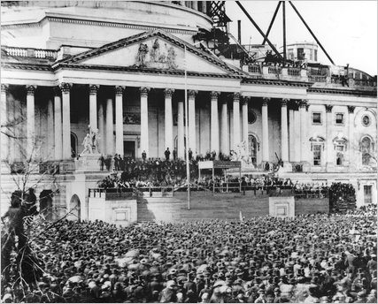
- Where was this photo taken?
- Trump Tower
- The White House
- The Disneyland Castle
- Fort Sumter What was Lincoln the president
- What has Lincoln’s main goal during his presidency?
- To stop slavery once and for all
- To preserve the manufacturing of Doritos
- To preserve the Union
- To catch all 718 Pokémon
- What was Lincoln the president of?
- The Galactic Empire
- The United States of America
- SHIELD
- The Confederate States of America
- True or False: Lincoln originally wanted only the
expansion of Slavery to end.
- True
- False
- The answer is either A or B

