Name_________________
Date________
Period___
Dred Scott Vs SandFord
H: March 6th 1857. Supreme Court

I: Officials of Supreme Court, and blacks

P: To argue his freedom due to him living in a free state

P: Dred Scott’s view of freedom and Taney’s view of Black’s rights

O: Idea that blacks aren’t equal still happens to this day occasionally; blacks have the same rights as any other race. We are all equal.

S: Missouri Compromise (1820) and south succession from union (1860-1861)

- Who was Dred Scott?
- Slave B. Lawyer
C. Slave Owner D. None of the above
2. What year did the case happen?
A. 1861 B. 1855
C. 1857 D. 1860

3. Was Taney for slavery or against?
A. Pro-Slavery B. Anti-Slavery

4. What happened 3 years after the Dred
Scott Decision?
- Civil War B. South Succeeds
C. Panic of 1857 D. Missouri Compromise

5. Did Dred Scott win the case?
- Yes B. No

Name___________

Date_________

Period___

The Emancipation of Negroes, January 1863, the past and the Future
3. What word is on the stove?
A. Union B. CSA
C. USA D. Confederacy

4. What is happening to the slaves in the bottom left?
A. Working B. Being beaten
C. Arguing D. Escaping

H: January 24th 1863, 13 days after Emancipation Proclamation

I: Union and Republicans

P: To remind union what they are fighting for

P: Against slavery

O: Weak cause at first but then morally improved

S: Reconstruction era: Freedmen’s Bureau

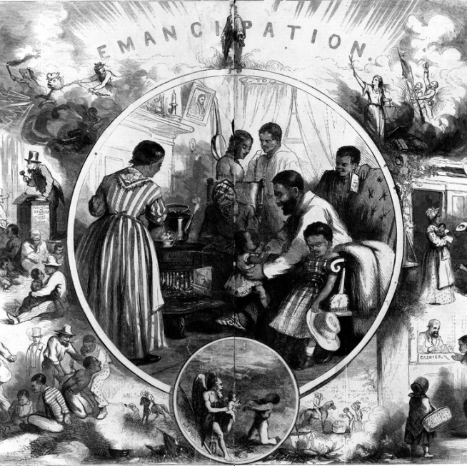

- What word is on the top of the picture
- Freedom C. Slavery
- Union D. Emancipation

- Who is on the picture on the wall inside
the bubble?
- Washington C. Adams
- Lincoln D. Johnson

