Key Period 5 (1844-1877) Inaugural Speeches
Title:
Observe this piece of historical sweg!
HIPPOS notes (Does NOT have to be in full sentences):

H- Jefferson Davis’s first Inaugural Address: February 18th 1861 around two months before the start of the Civil War.

I- Southerners/Confederacy

P- To tell the Confederacy that they will protect their rights and that the Union are infringing upon their rights so their secession was just to promote their own welfare.

P- Davis was raised in the Southern cotton plantations and he thought that it was a right to own slaves. He firmly believed that slavery was “a positive good”

O- His ideas were very different from many Northerners like Lincoln who thought slavery was a “necessary evil”

S-Davis’s ideas combined with others led to the Civil War where he was the president of the confederacy and in charge of the war planning

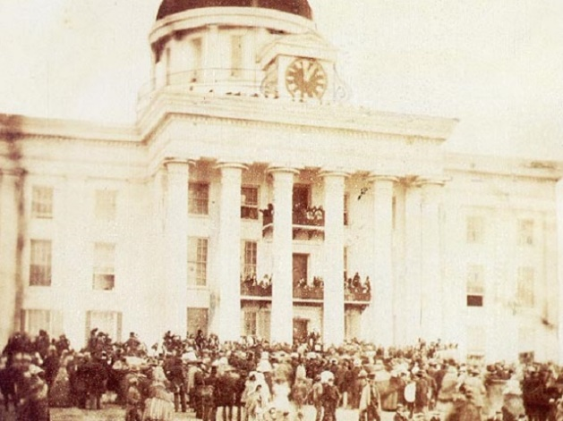
- Where was this photo taken?
- The Secret Illuminati Capital
- Alabama State Capital
- The White House
- Plantation owner’s home
- What was Jefferson Davis the president of?
- The Mushroom Kingdom
- The United States of America
- The Confederate States of America
- The Pokémon Fan Club
- What was the Confederacy fighting for?
- The Liberation of France
- The Last $100 100 inch TV on Black Friday
- The preservation of Slavery
- The end of Slavery
- Why did the Confederate States Secede?
- Lincoln ate a Southerner’s cookies
- The production of Doritos has stopped
- Lincoln winning the Election of 1860
- They found out the apush final isn’t curved

Key Period 5 (1844-1877) Inaugural Speeches
Title: Abraham Lincoln’s first inaugural address
Observe this piece of historical sweg!
HIPPOS notes (Does NOT have to be in full sentences):

H- Lincoln’s First Inaugural Address: March 4, 1861 at the White House around the time the Civil War first started

- Northerners/Unionists

P- To reassure the people of the United States that we will get through any hardships with victory without needing to rid it of slavery

P- Lincoln’s/Free-Soiler’s perspective that slavery doesn’t need to end but just the expansion of it in order to preserve the Union.

O- Different from Lincoln’s second address where he announces that he might have to free slaves in order to preserve the Union which goes against what he first said.

S- Can be compared to the Wilmot Proviso which banned slavery in Mexican Cession land which was supported by Lincoln and the Free-Soilers.

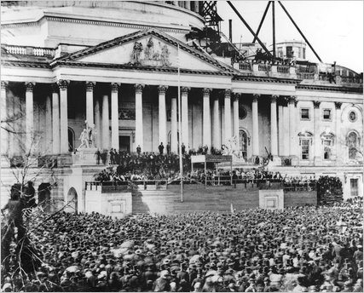
- Where was this photo taken?
- Trump Tower
- The White House
- The Disneyland Castle
- Fort Sumter What was Lincoln the president
- What has Lincoln’s main goal during his presidency?
- To stop slavery once and for all
- To preserve the manufacturing of Doritos
- To preserve the Union
- To catch all 718 Pokémon
- What was Lincoln the president of?
- The Galactic Empire
- The United States of America
- SHIELD
- The Confederate States of America
- True or False: Lincoln originally wanted only the
expansion of Slavery to end.
- True
- False
- The answer is either A or B

